BSAN 450 Assignment 13

1) The data for this problem is total private construction spending – not seasonally adjusted January 2002 to March 2014. The data is in a file named ConstructionSpending.csv. The variable name is Private.

a) Read the data into R Studio. Plot the data and appropriate differences to identify a model to fit to this data.

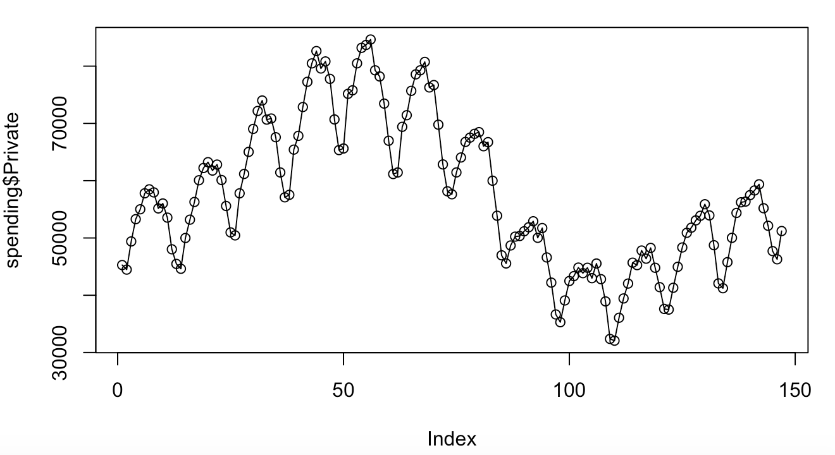

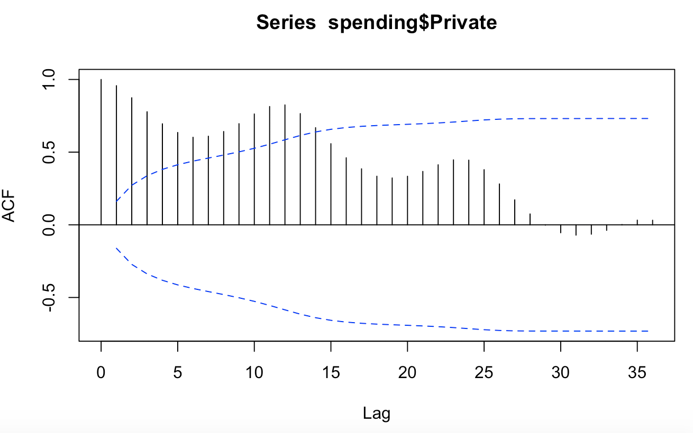

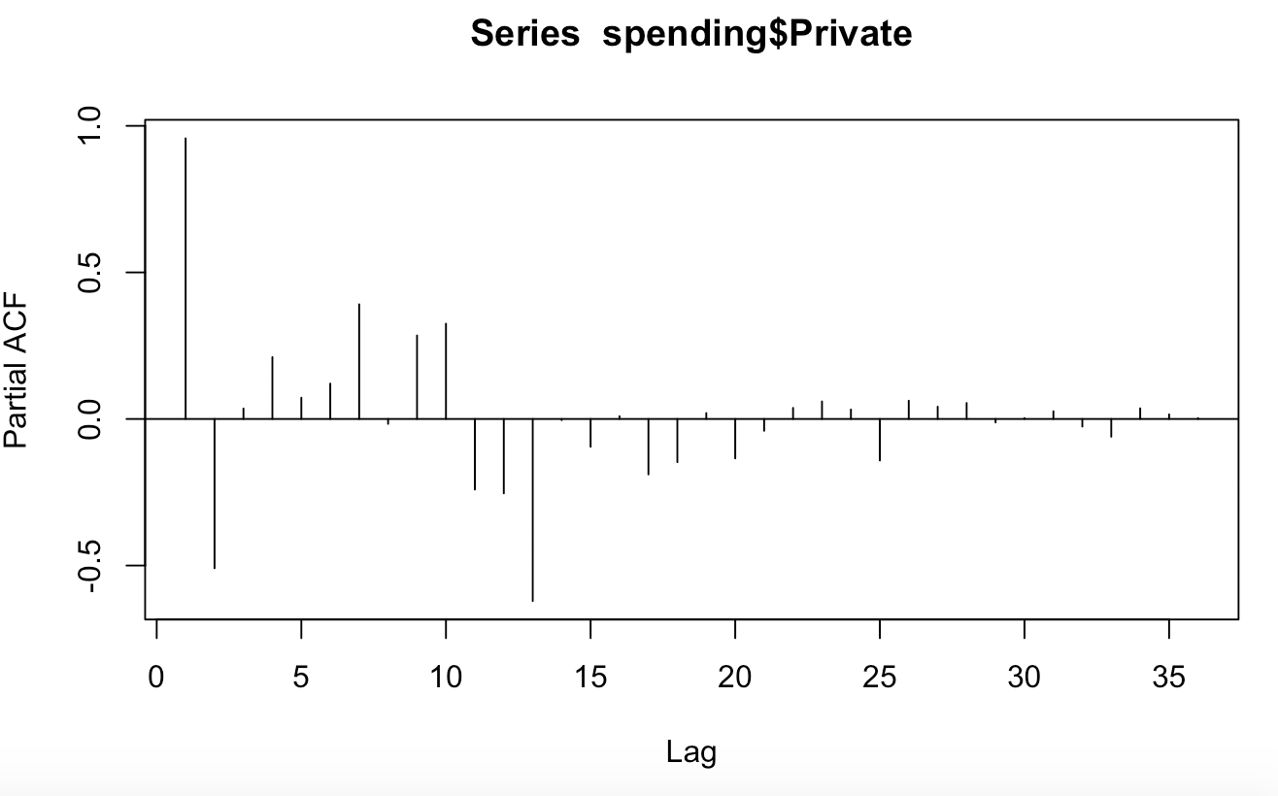

**The data has a seasonal trend**

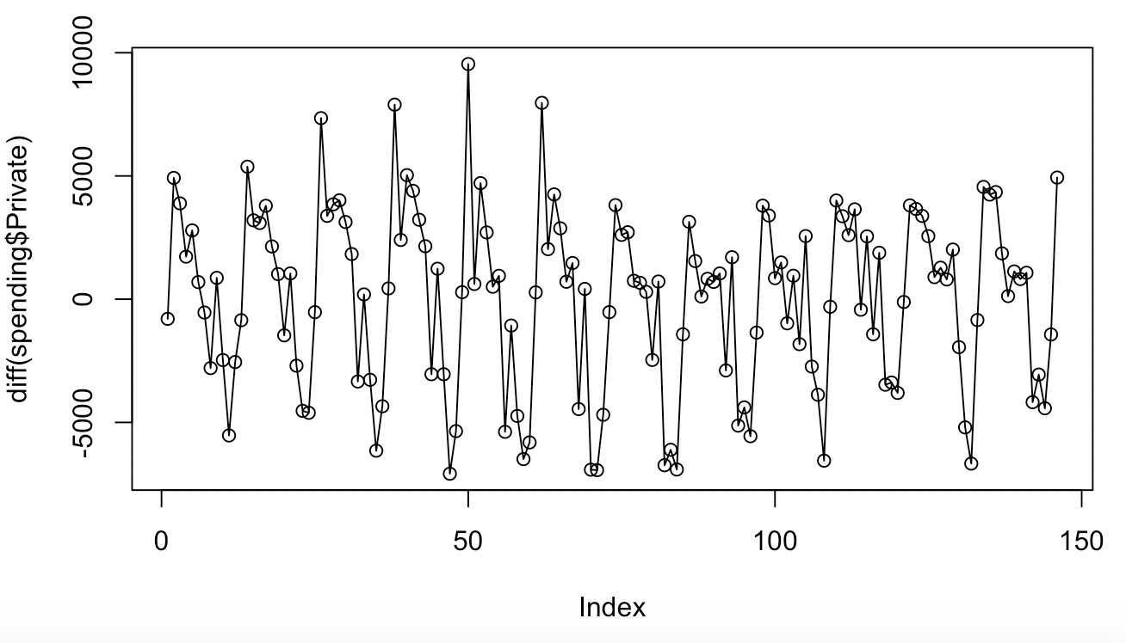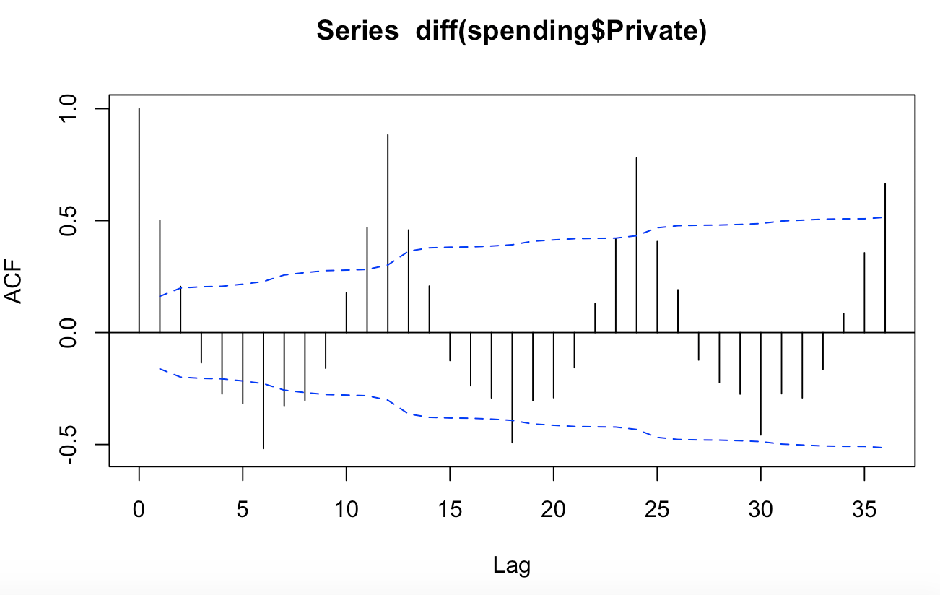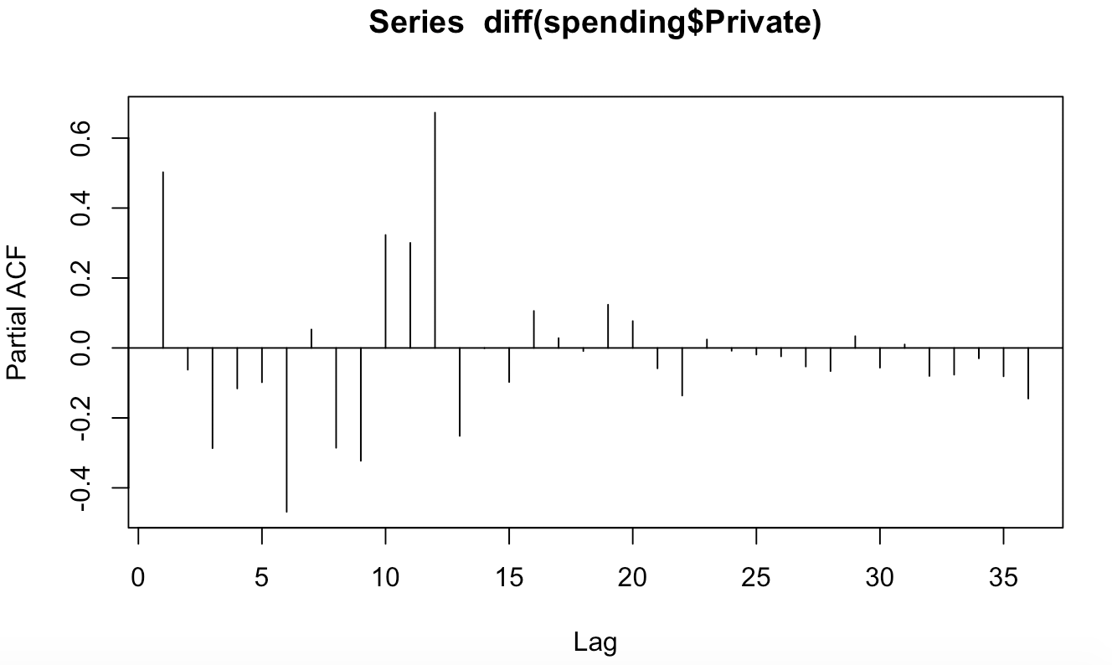

**The ACF for the first difference shows spikes at multiples of 12 indicating a seasonal pattern.**

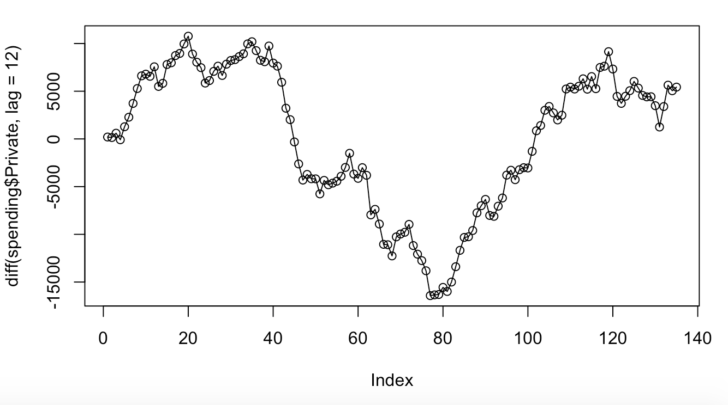

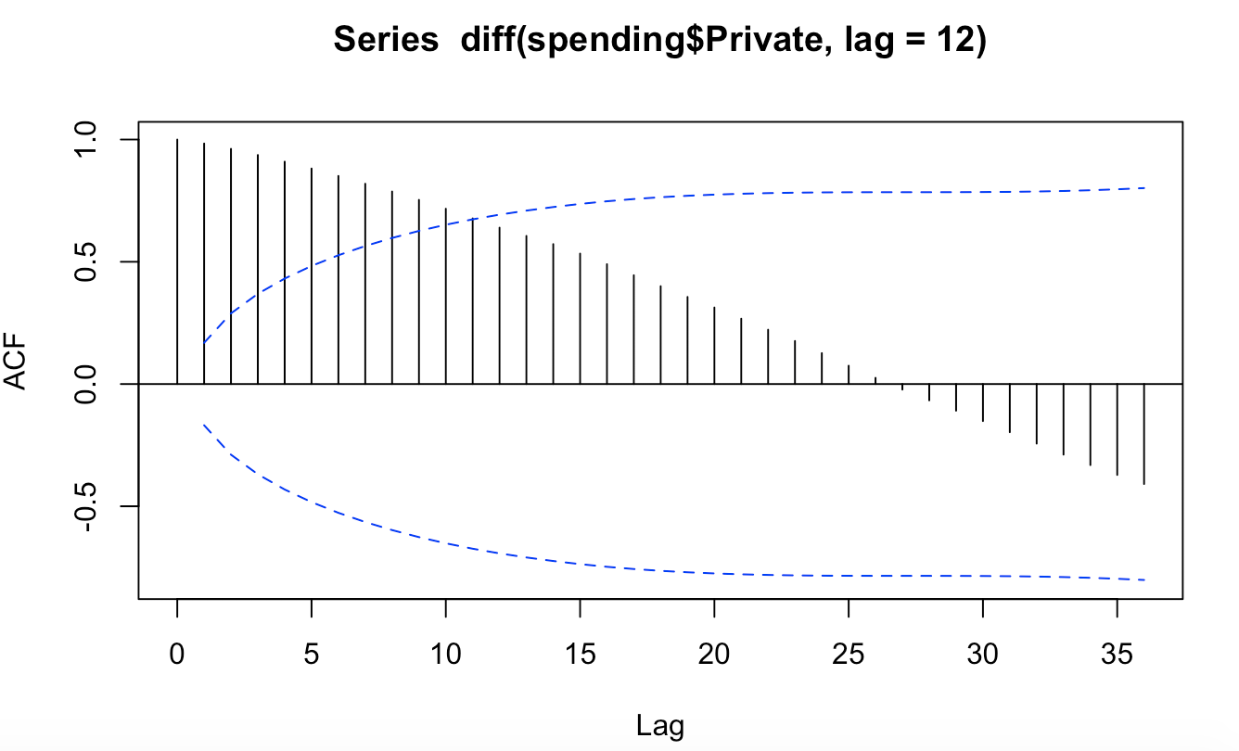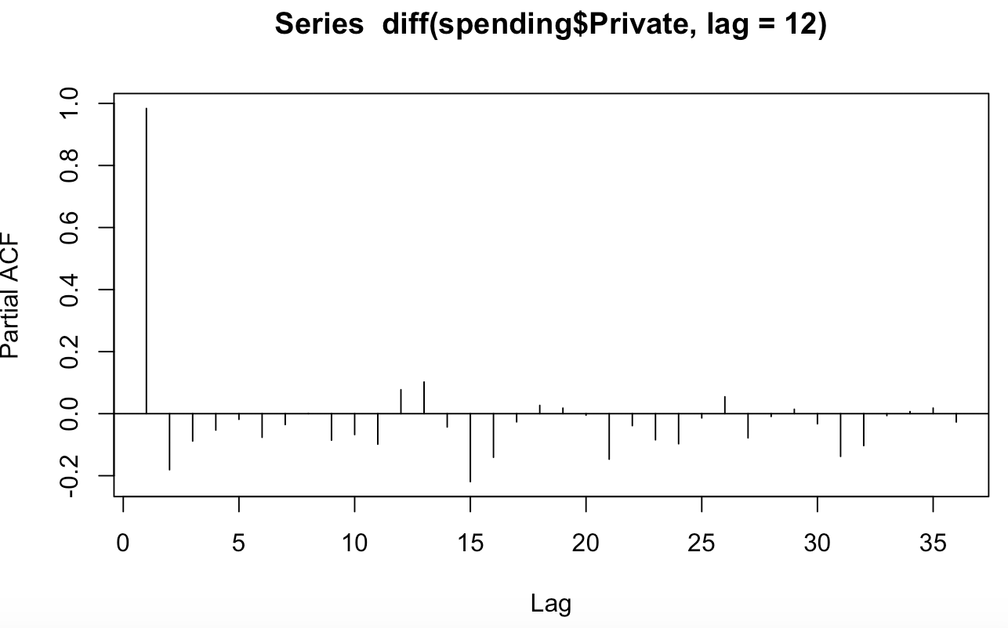

**The ACF for the first difference indicates the first difference is needed because it is decreasing slowly in a linear fashion.**

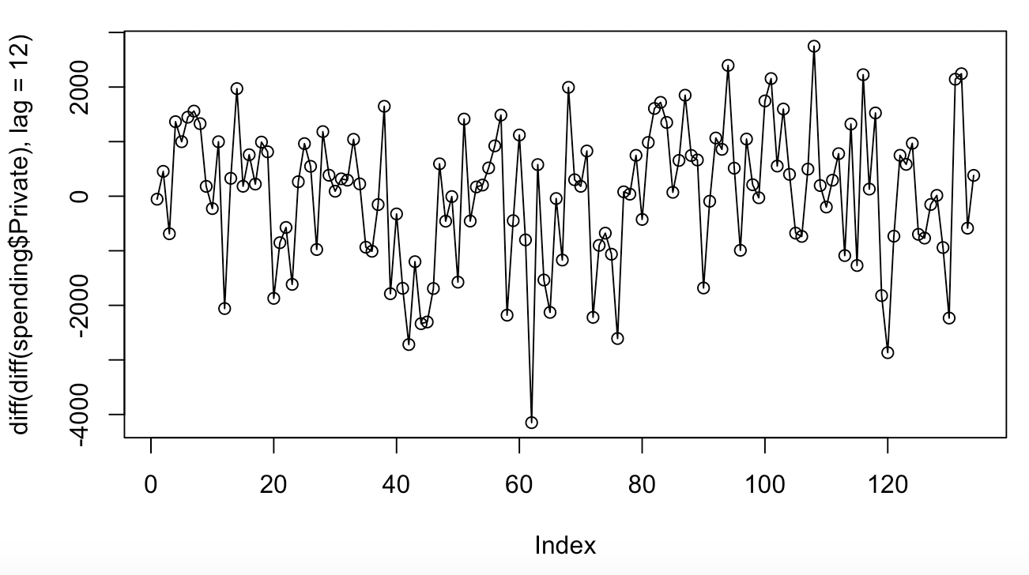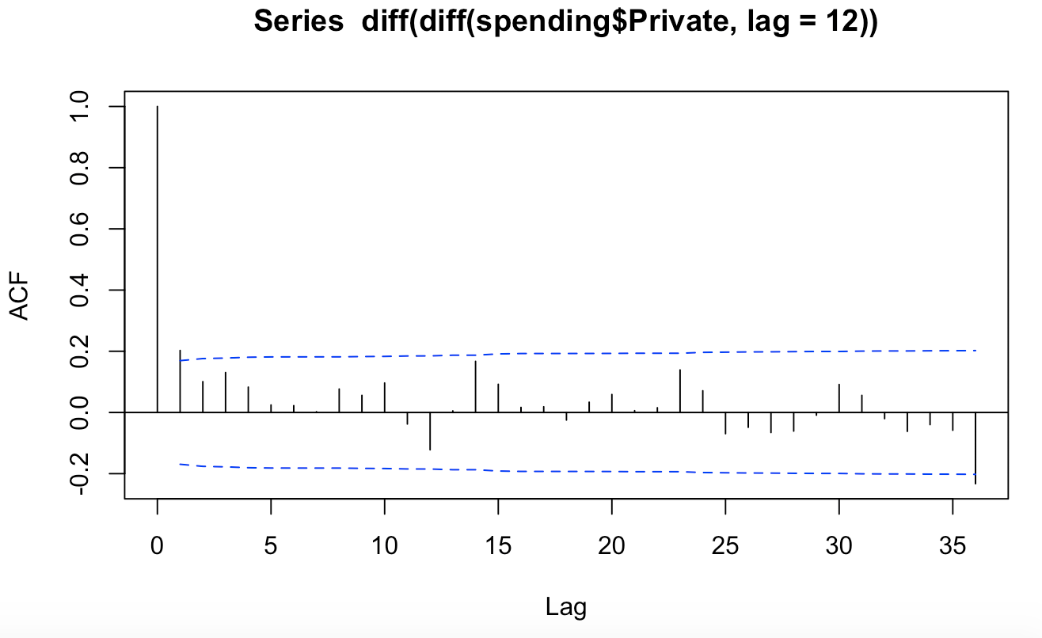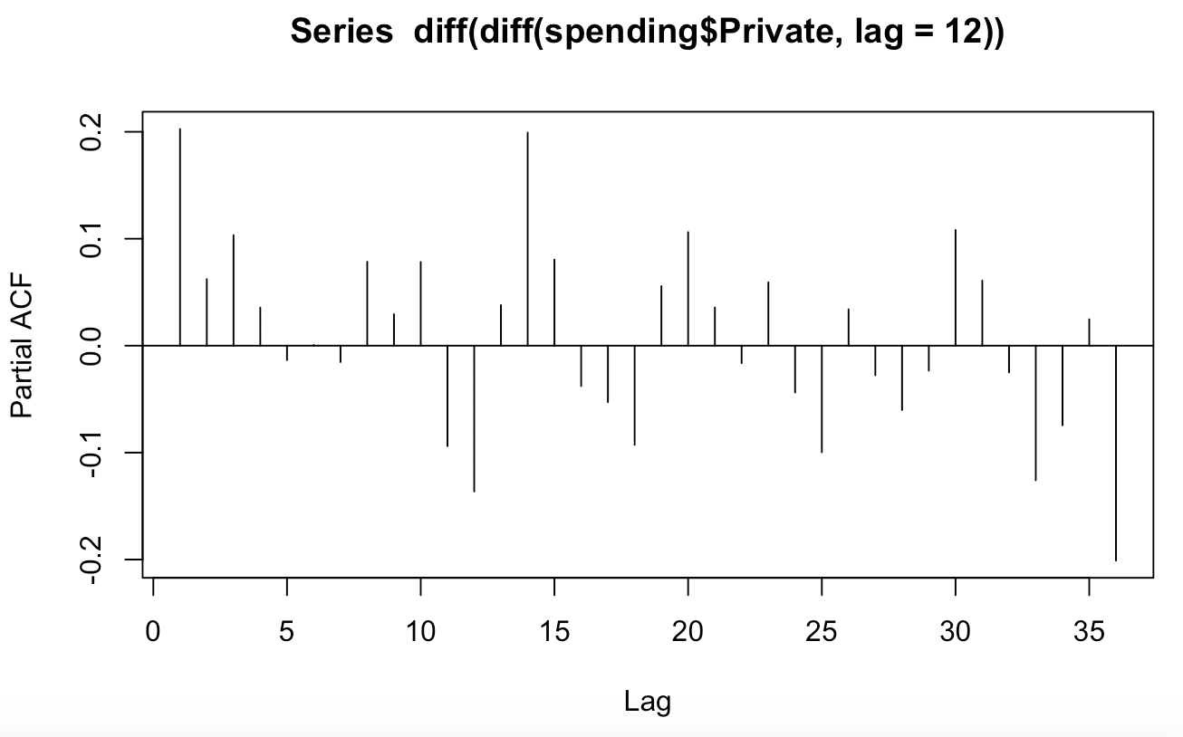

**This looks stationary. An MA(1)*SMA(1) model looks appropriate.**

b) Estimate the model you identified in part a). Perform diagnostic checks for this model.

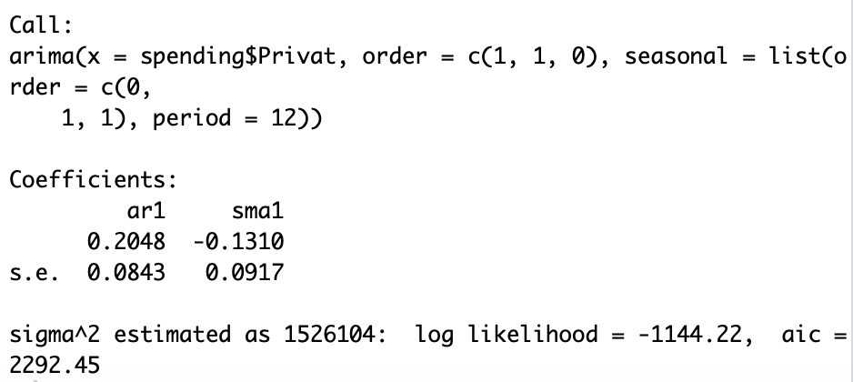

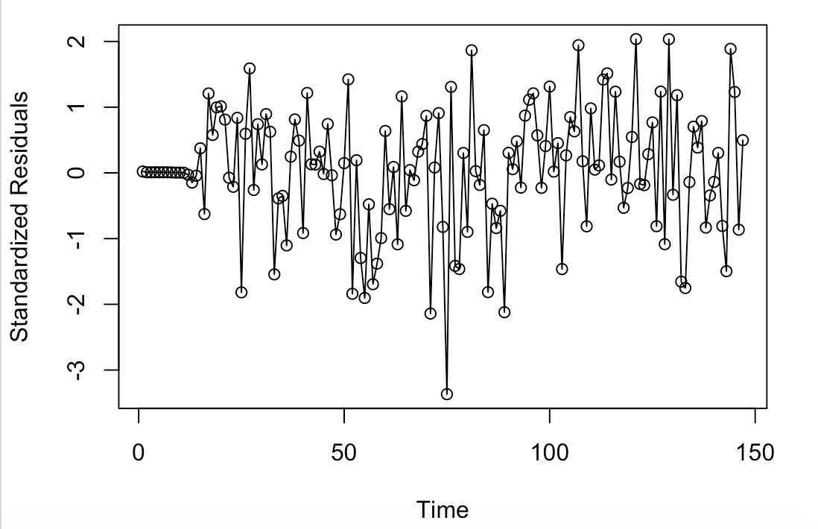

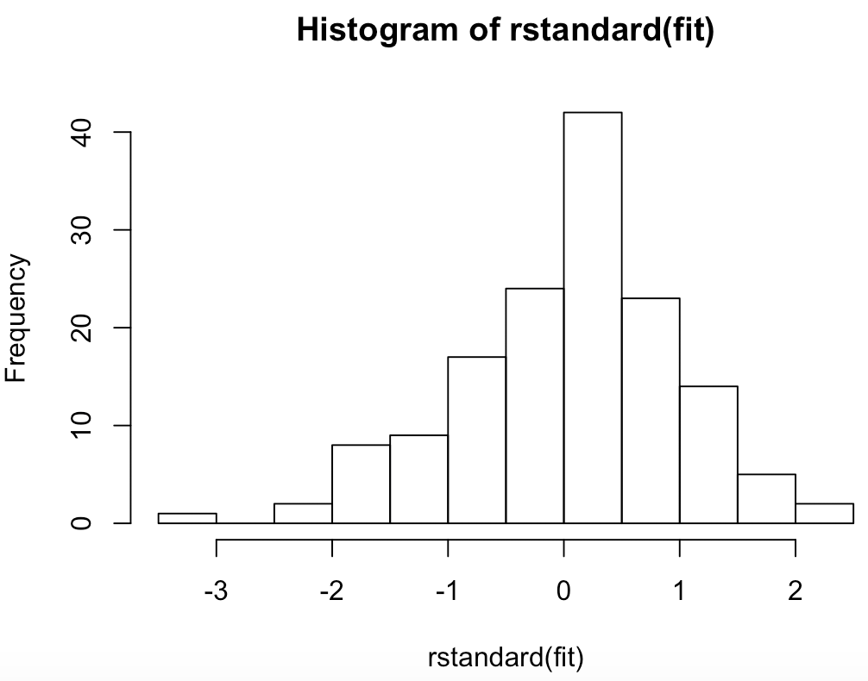

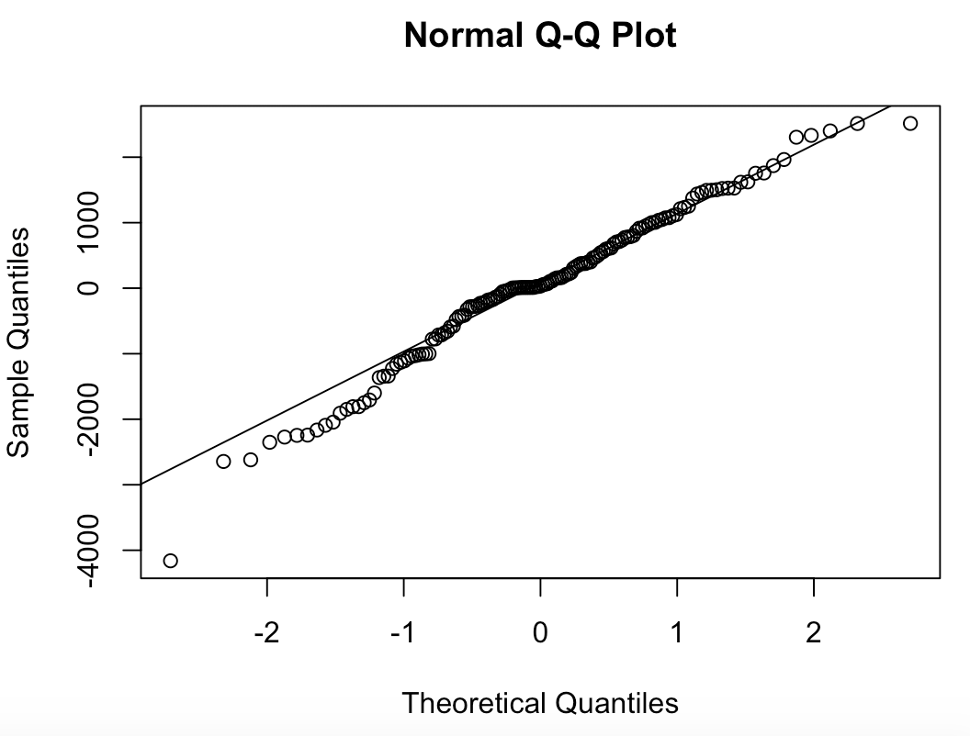

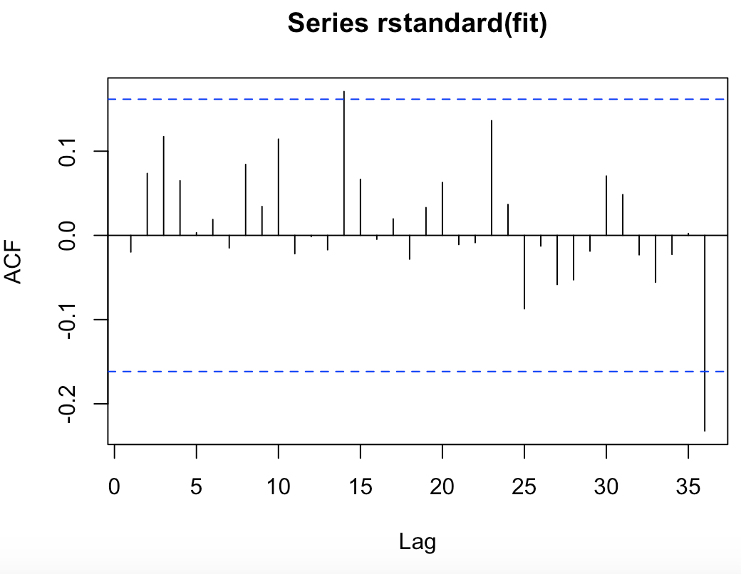

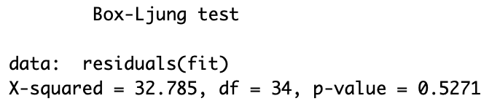

**The diagnostics do not indicate an issue with this model.**

c) Check for outliers. The R commands to do this follow (in these commands the expression nameofmodel is the name you gave to the time series model).

detectAO(nameofmodel)

detectIO(nameofmodel)

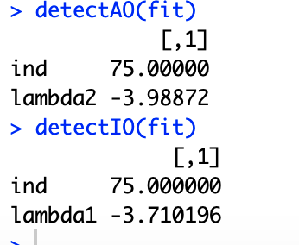

d) Since there is a possible outlier at time 75 modify the model to include the possibility of this outlier. The R commands to fit an additive outlier are.

AO75=1*(seq(timeseriesname)==75)

xreg=data.frame(AO75)

fit1=arimax(timeseriesname,order=c(0,1,1),xreg,seasonal=list(order=c(0,1,1),period=12))

fit1

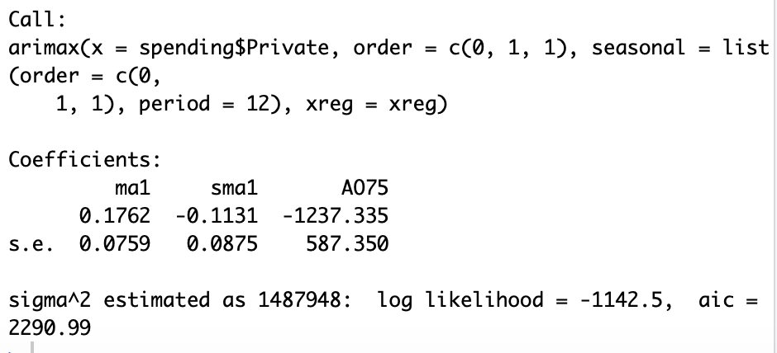

The R commands to fit an innovation outlier are.

fit1=arimax(timeseriesname,order=c(0,1,1),seasonal=list(order=c(0,1,1),period=12),io=c(75))

fit1

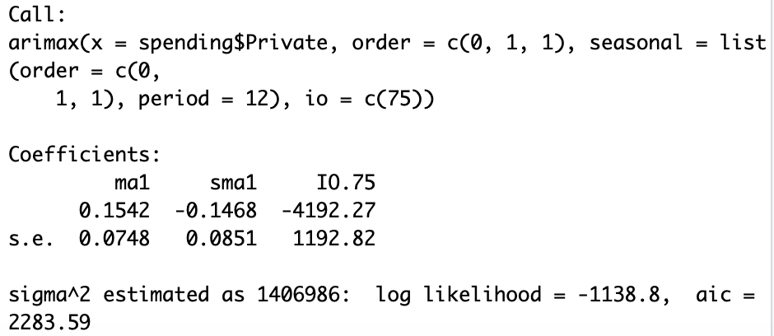

2) The data for this problem is the milk production for 168 months. The data is in a file named Milk.csv and the variable name is Production.

a) Read the data into R Studio and perform the necessary plots to identify a model for the data.

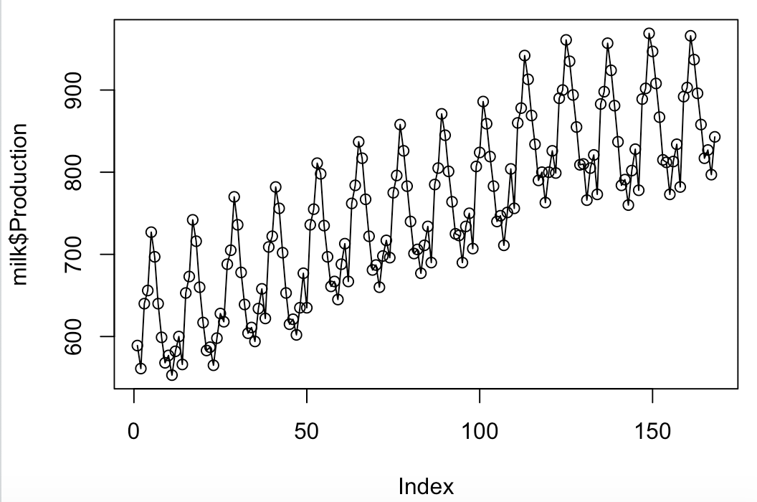 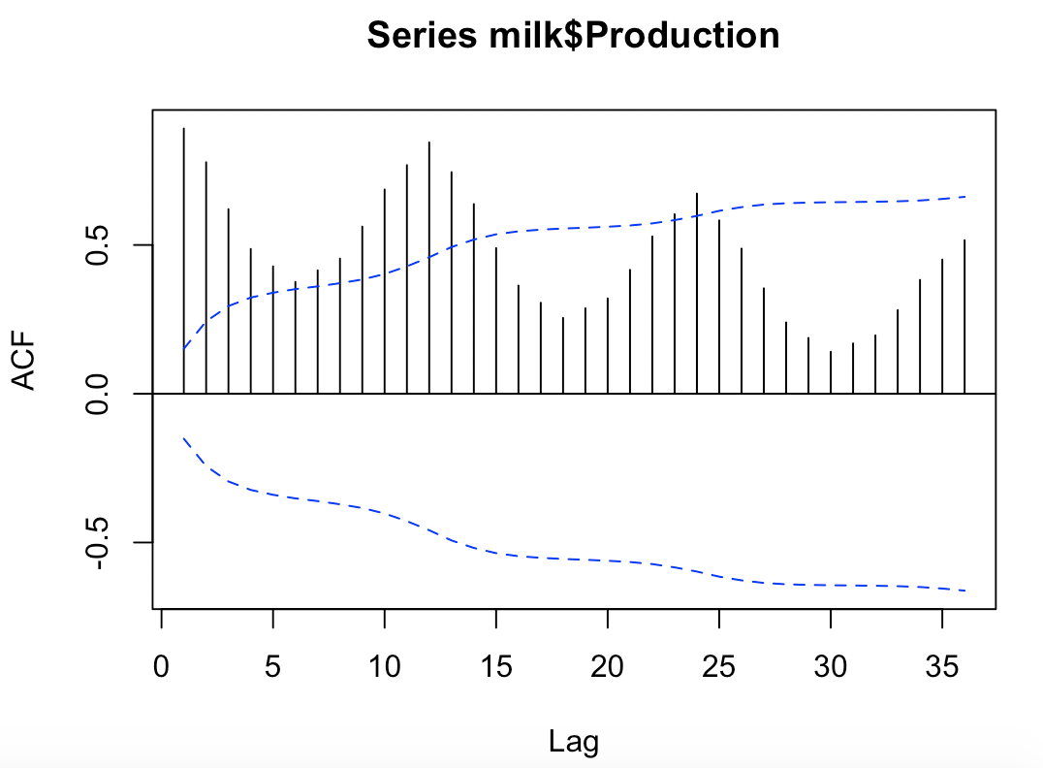 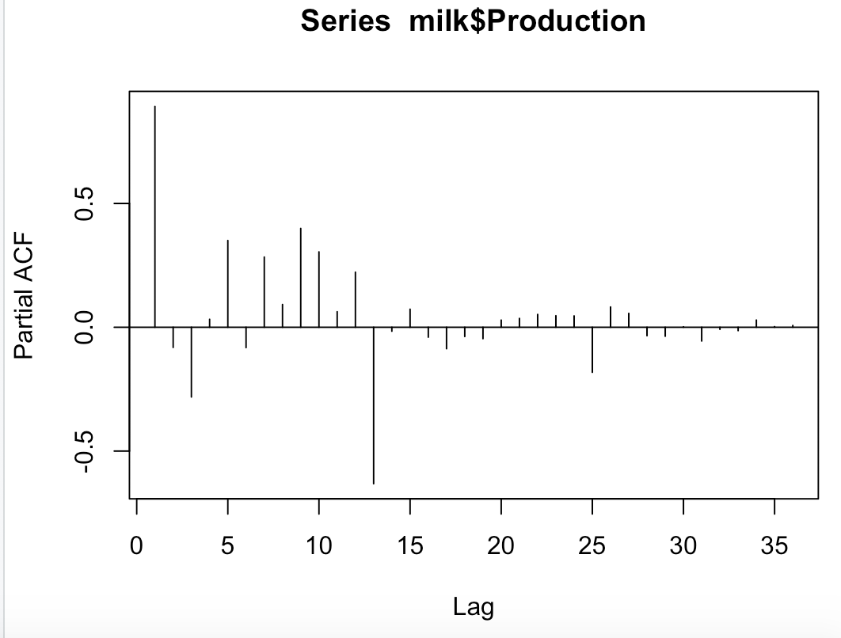

**Not stationary because there is a seasonal relationship**

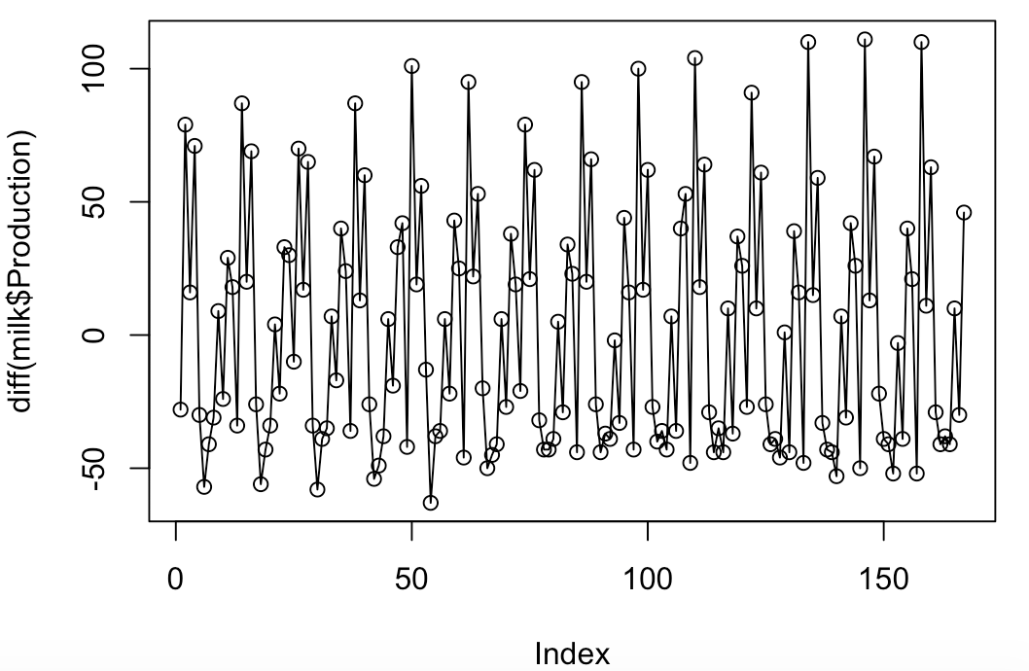 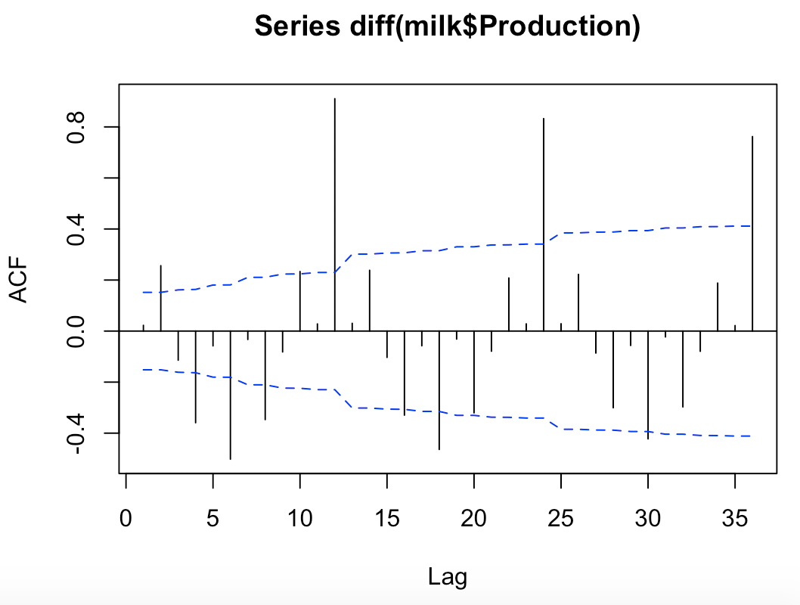 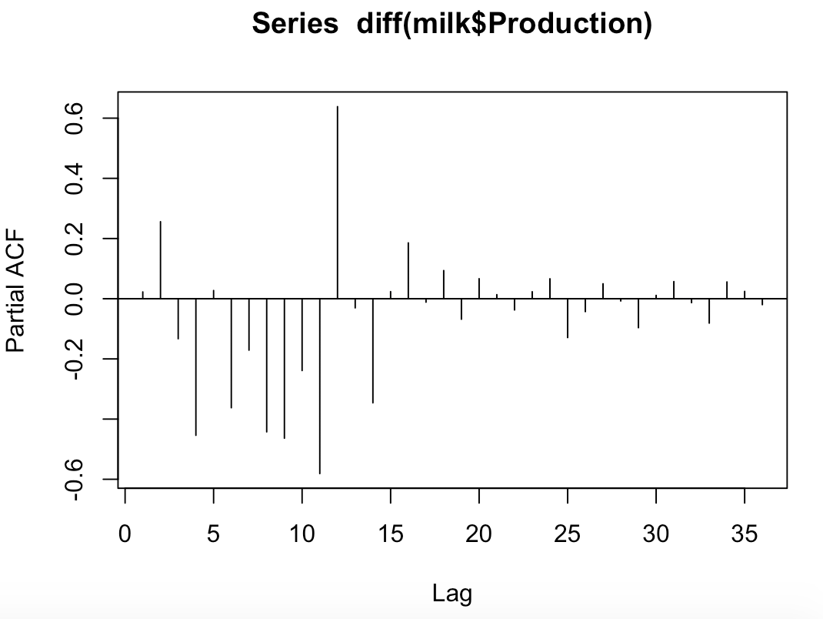

**Not Stationary. There is a seasonal pattern in the data.**

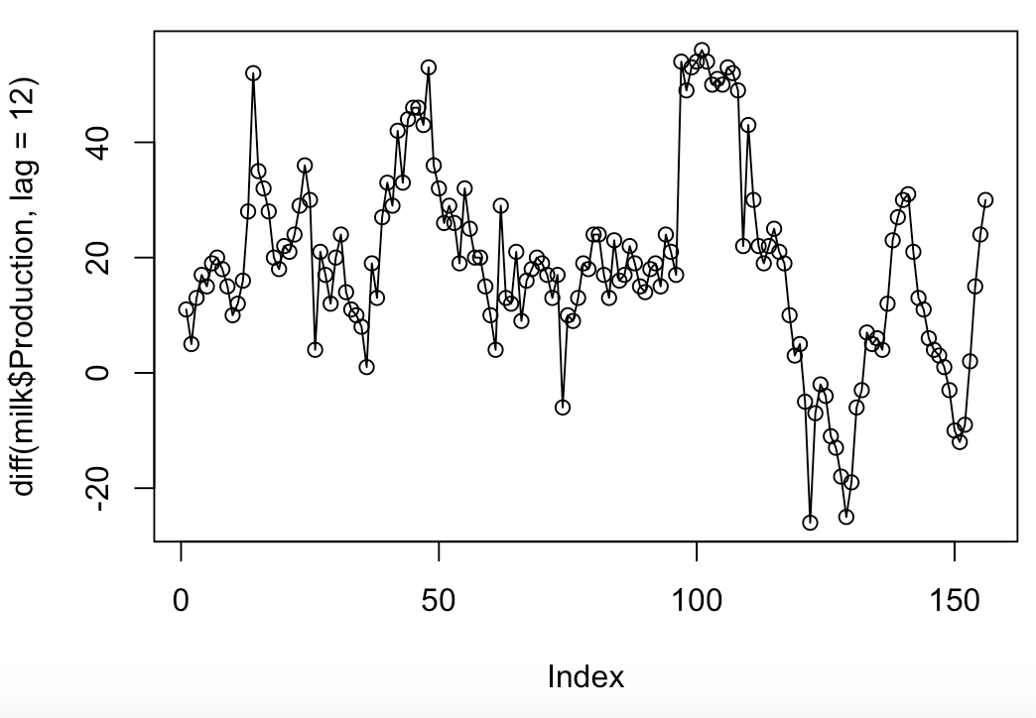

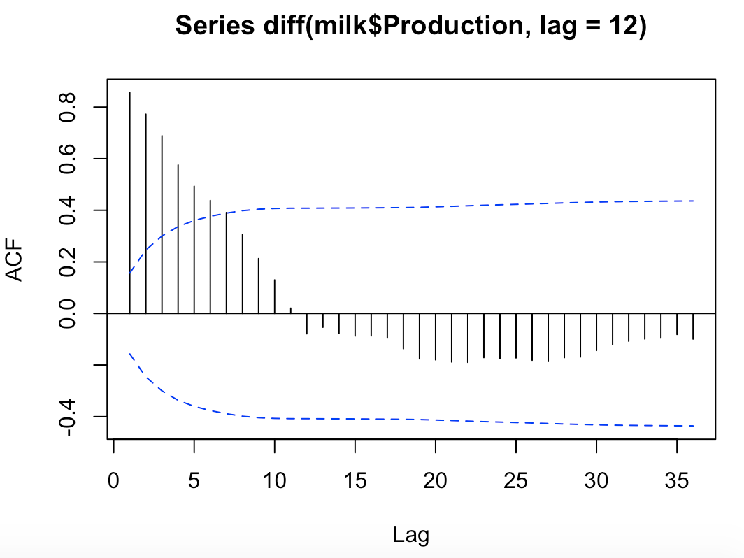 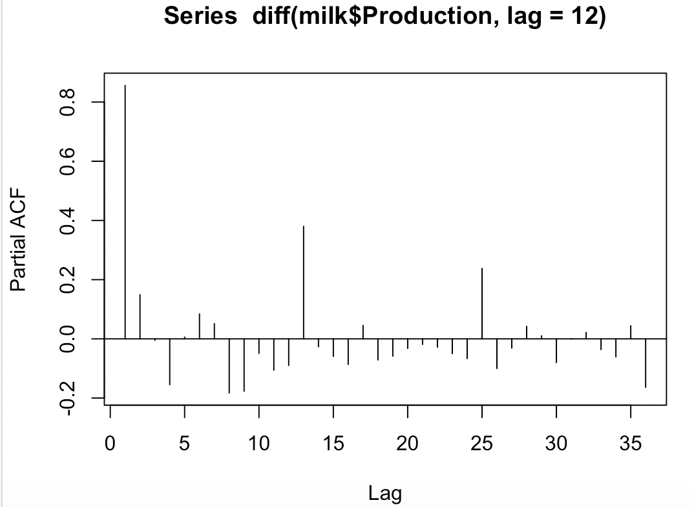

**The ACF is linearly decreasing, meaning this is not stationary.**

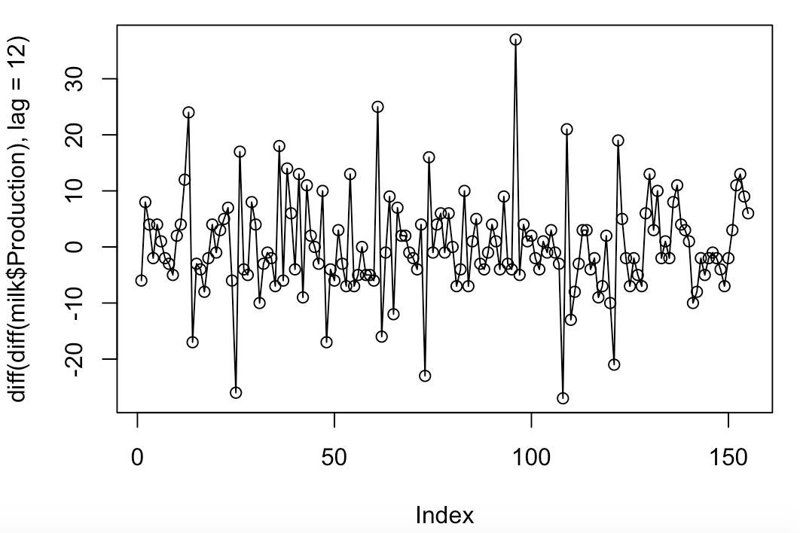

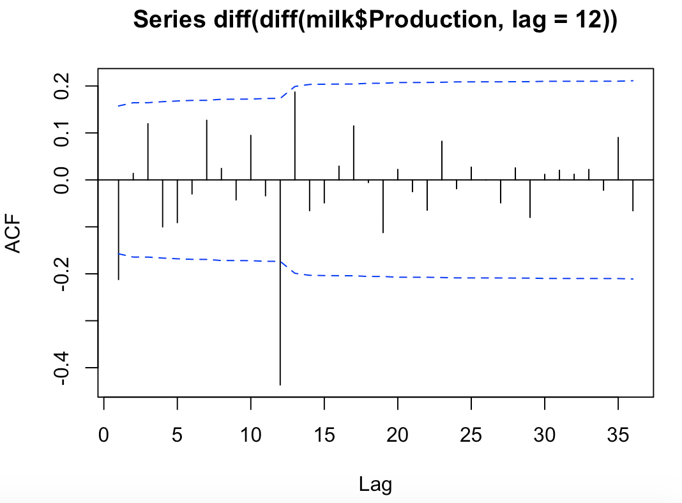

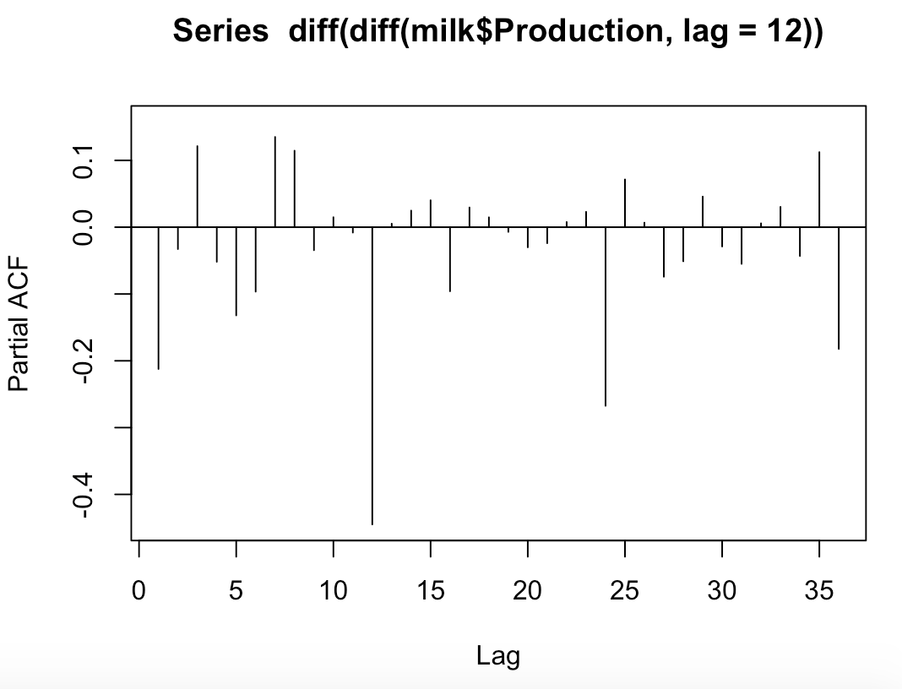

**This is stationary. Use model MA(1)*SMA(1)**

b) Fit the model you identified in part a. Check the residuals from this model.

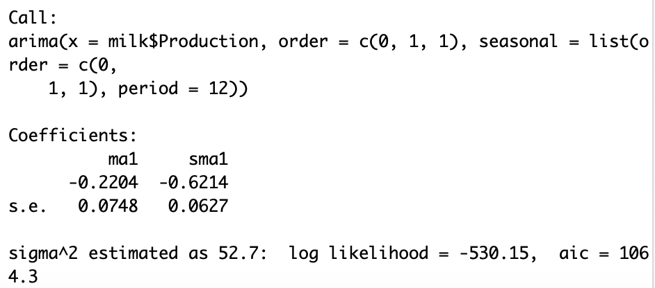

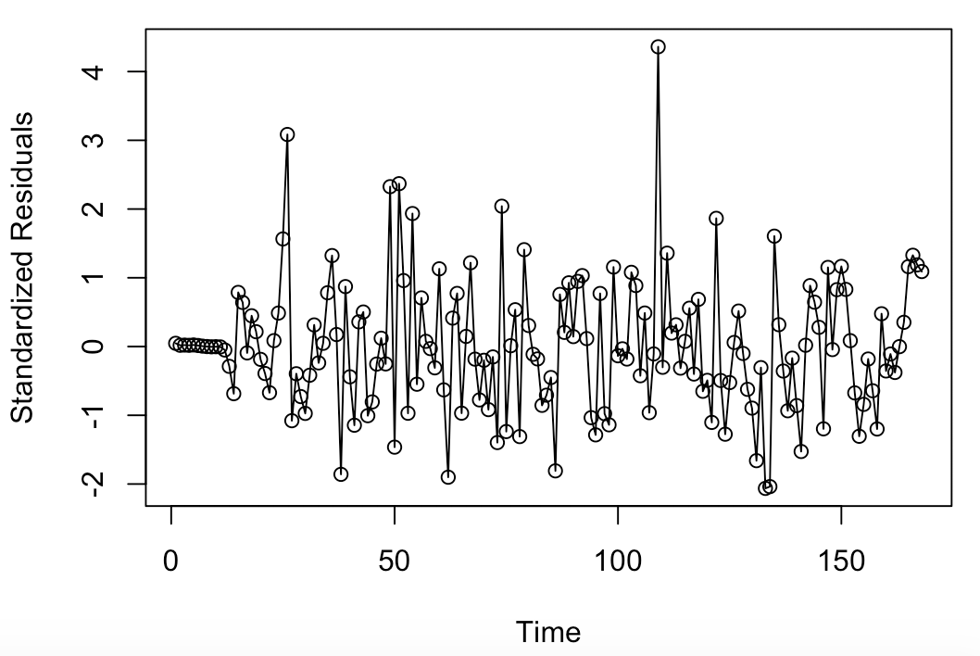 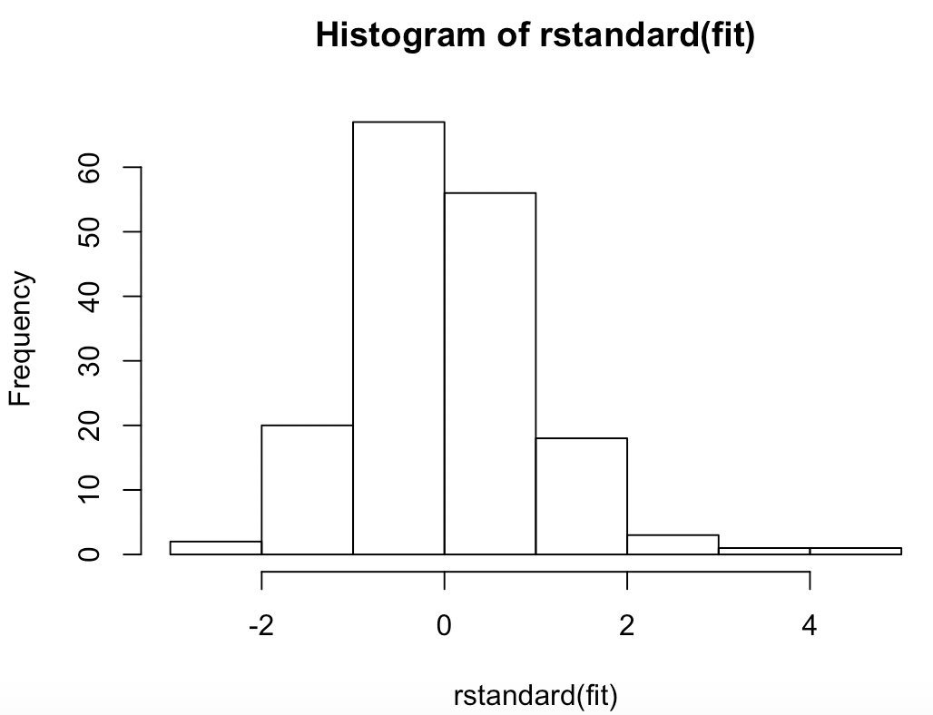

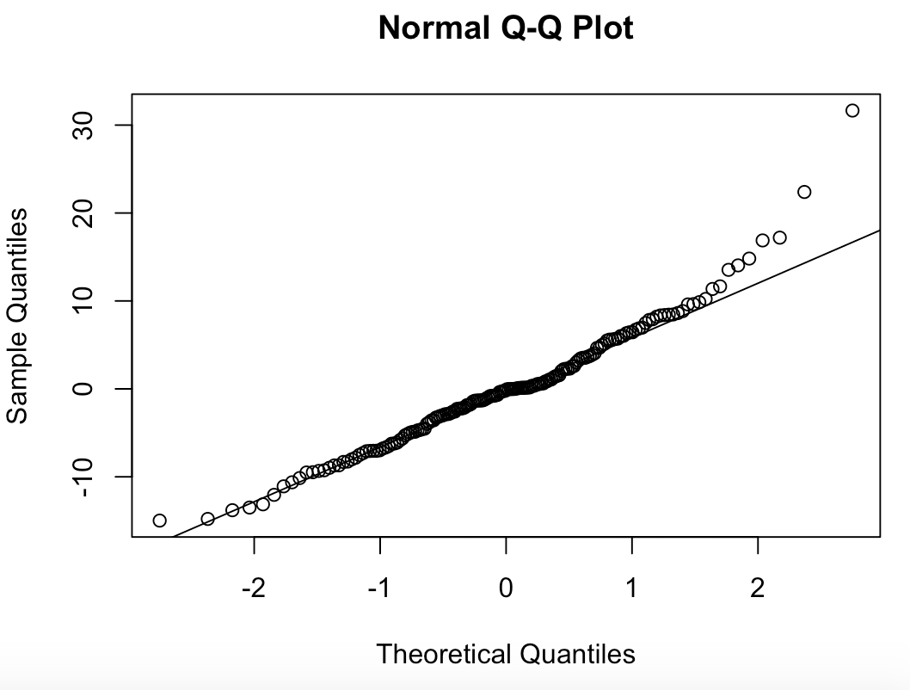

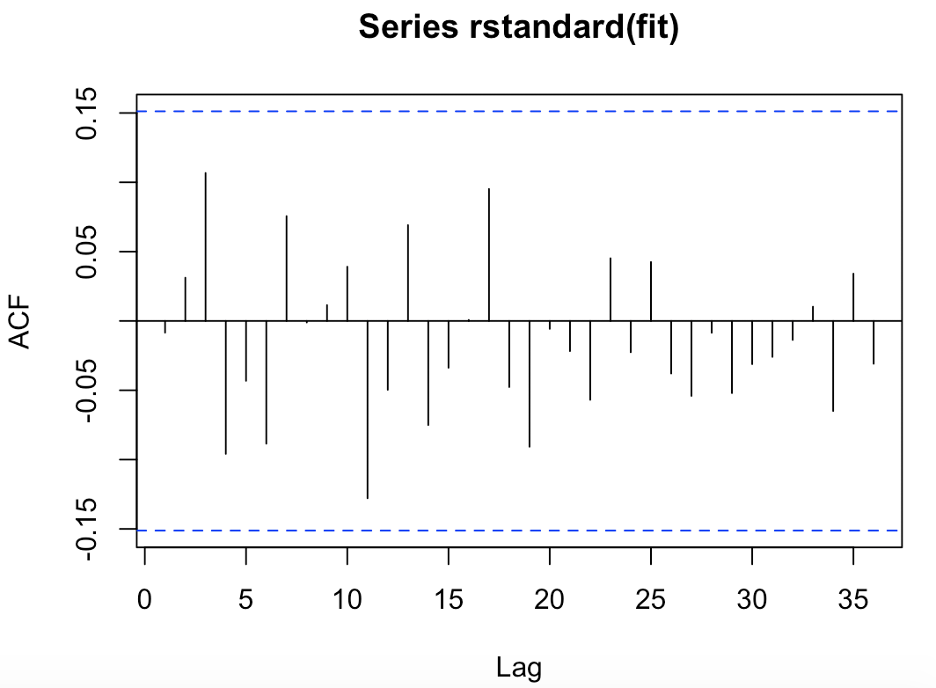

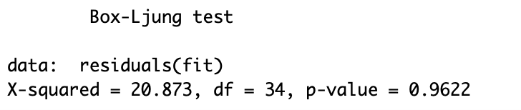

**The diagnostics do not indicate any issues with the fit of the model.**

c) Check for outliers in the residuals. If any outliers are detected, modify the model to include those outliers.

